Meet our Dynamic Denture Team
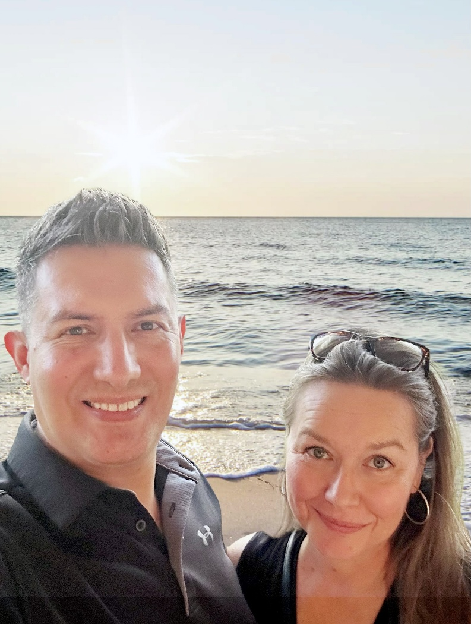
We are a small, dedicated team, working side by side to make sure your cases are treated with the attention they deserve.
Marcelo, CDT Certified Denture Technician, focuses on the technical, while Tara manages the workflow and communication to keep everything running seamlessly.
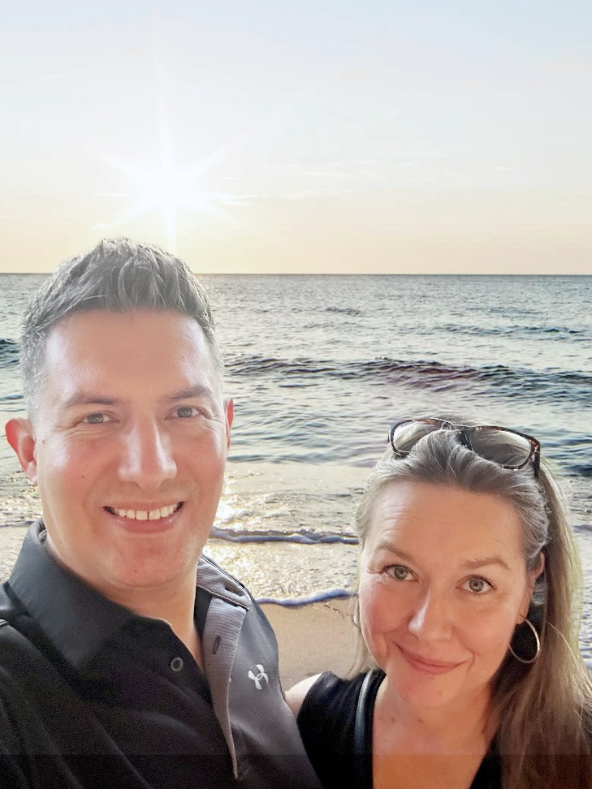
When you work with Dynamic Denture Designs, we provide you with consistent quality and dependable service - every case, every time.

Supporting your practice with care you can trust.

